SECTION -4

4-1 :- Conditional Control : IF Statements

IF Statement :-

CREATE A TABLE :-

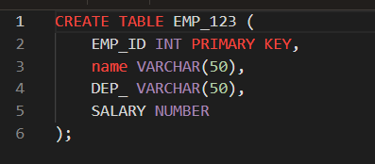

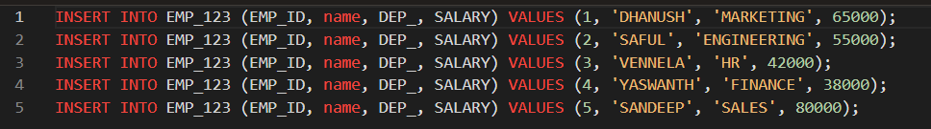

OUTPUT :-



USING IF, ELSE, ELSEIF CONDITIONS :-

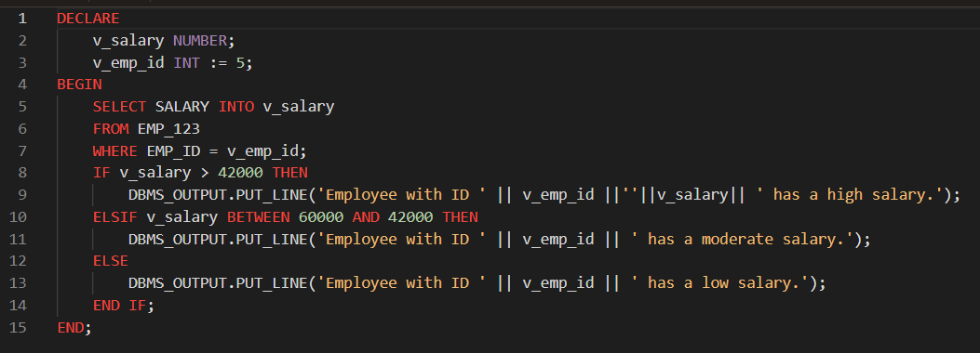



NULL VALUES IN IF STATEMENTS :-

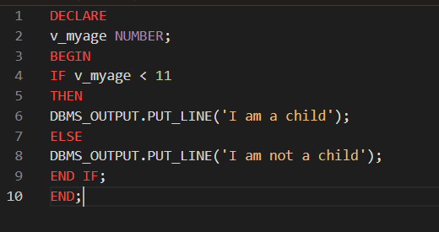

OUTPUT :-



4-2 :-

USING A CASE STATEMENT :-

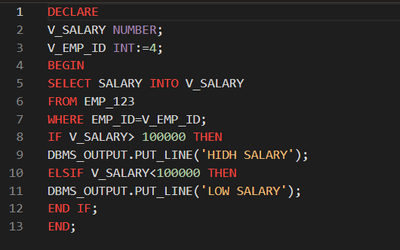

OUTPUT :-



CASE STATEMENTS :-

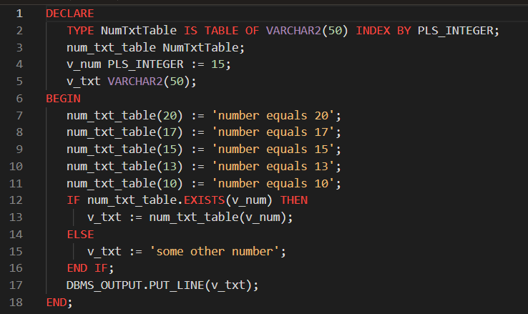



SEARCHED CASE STATEMENTS :-

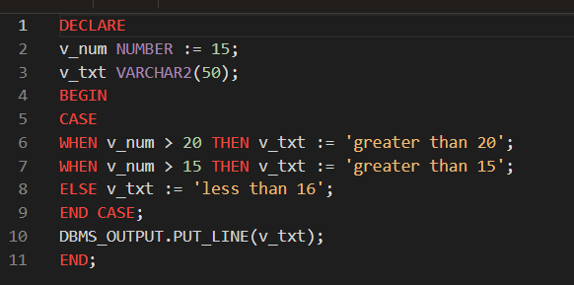



USING A CASE EXPRESSION :-

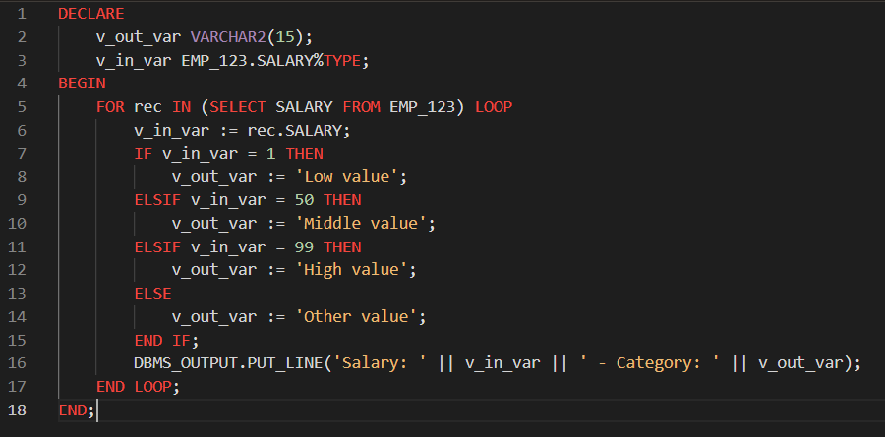

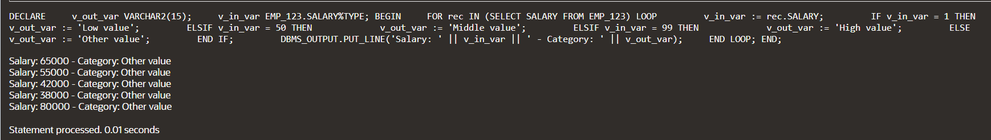

SEARCHED CASE EXPRESSIONS :-

CREATE A TABLE :-

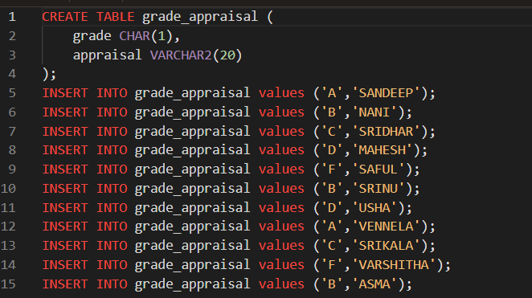

TABLE :-

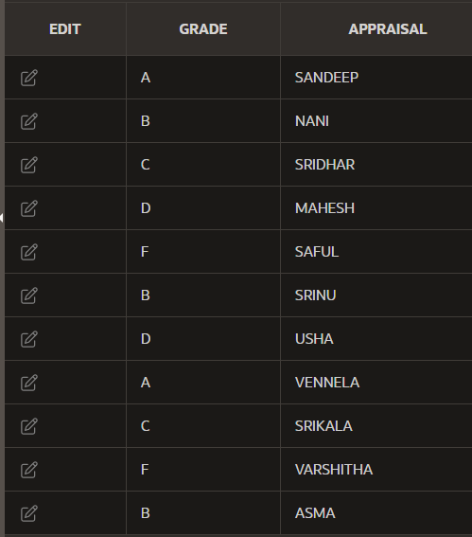

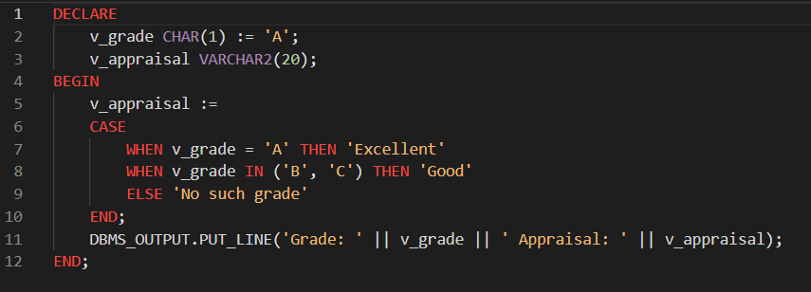

OUTPUT :-



4-3 :-

ITERATIVE CONTROL: BASIC LOOPS :-

BASIC LOOPS SIMPLE EXAMPLE :-

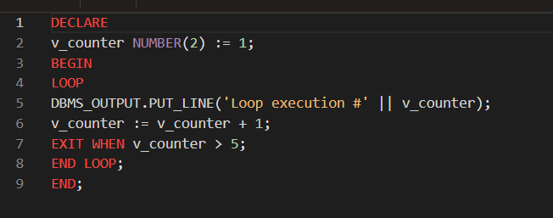

OUTPUT :-

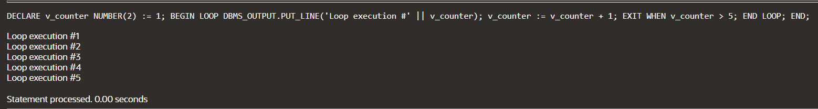

BASIC LOOPS MORE COMPLEX :-

CREATE A TABLE

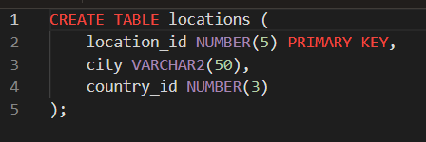

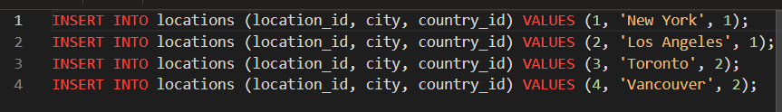

TABLE :-

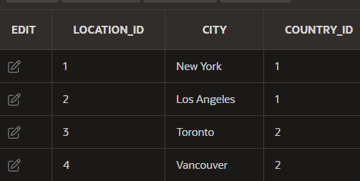

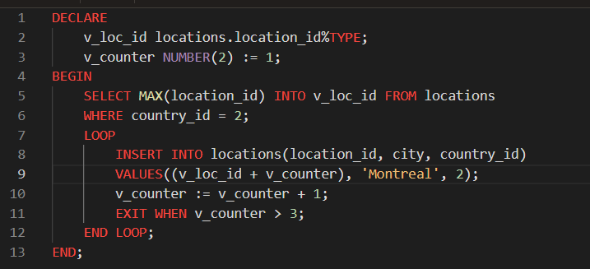

OUTPUT :-

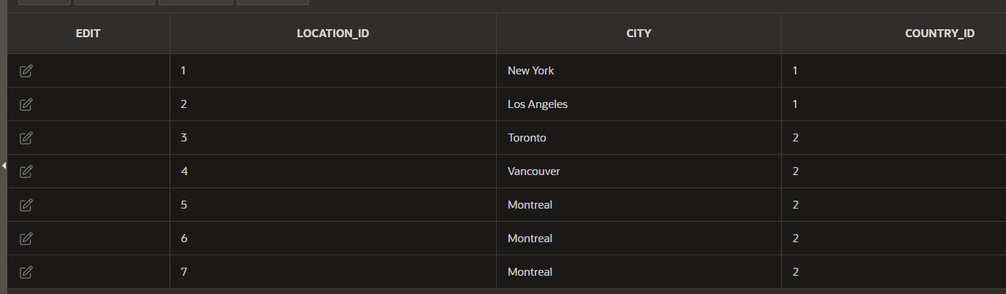

BASIC LOOPS EXIT STATEMENT :-

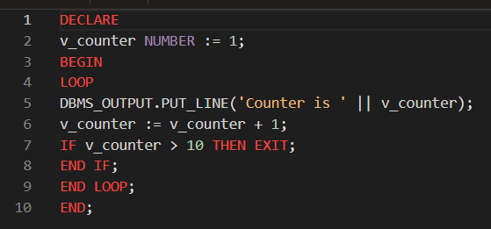

OUTPUT :-

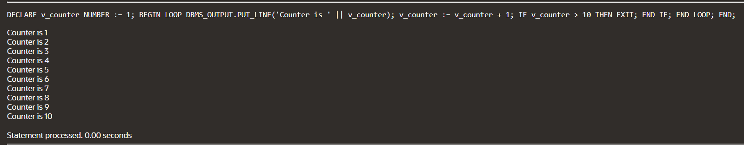

BASIC LOOP EXIT WHEN STATEMENT :-

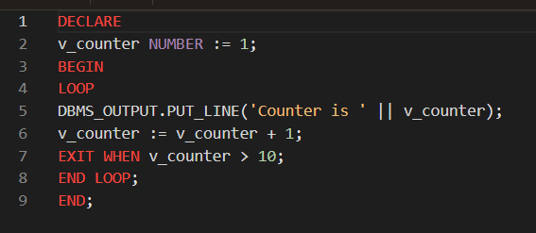

OUTPUT :-

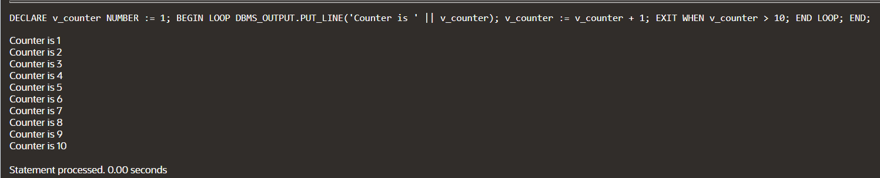

4-4 :-

ITERATIVE CONTROL: WHILE AND FOR LOOPS :-

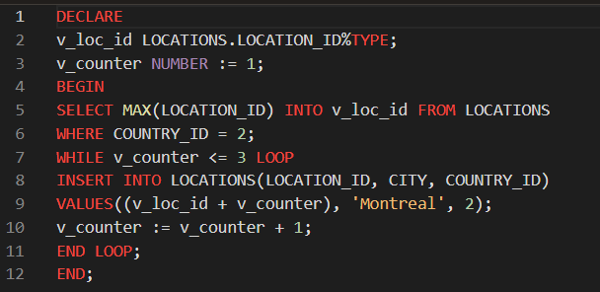

OUTPUT :-

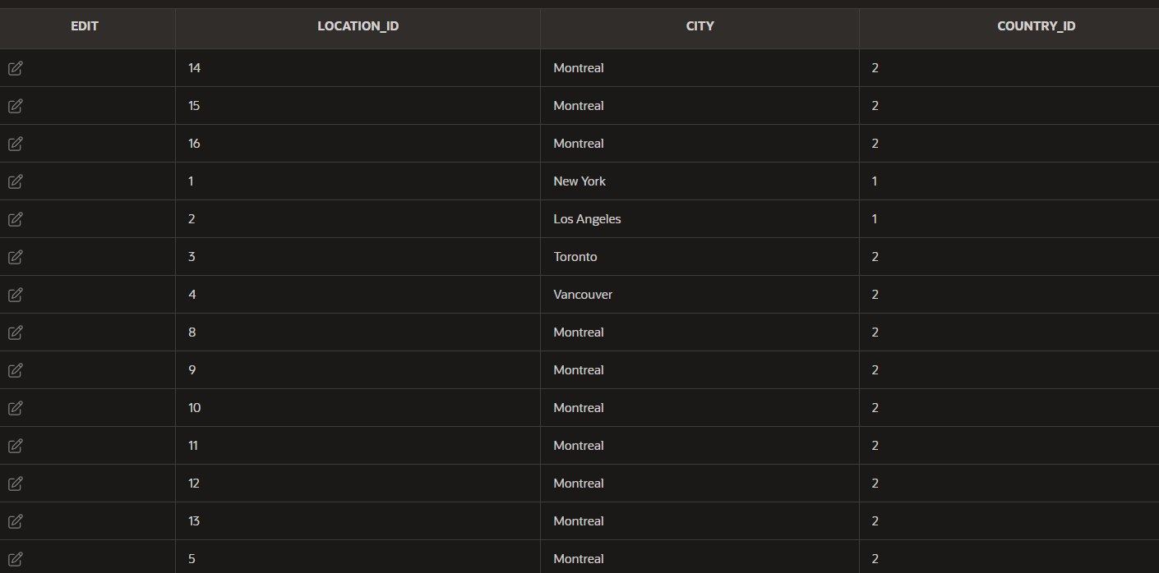

FOR LOOP :-

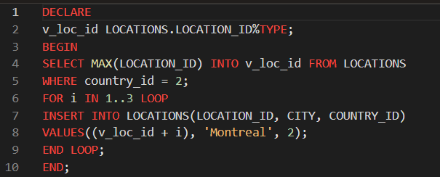

OUTPUT :-

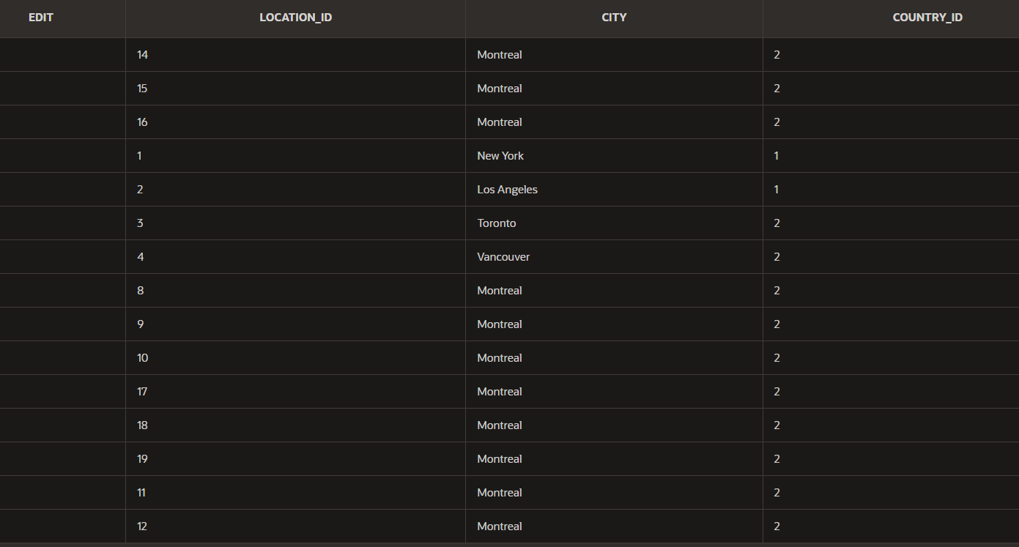

FOR LOOP EXPRESSION :-

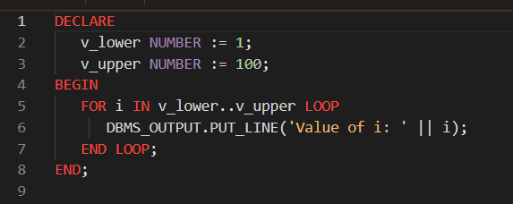

OUTPUT :-

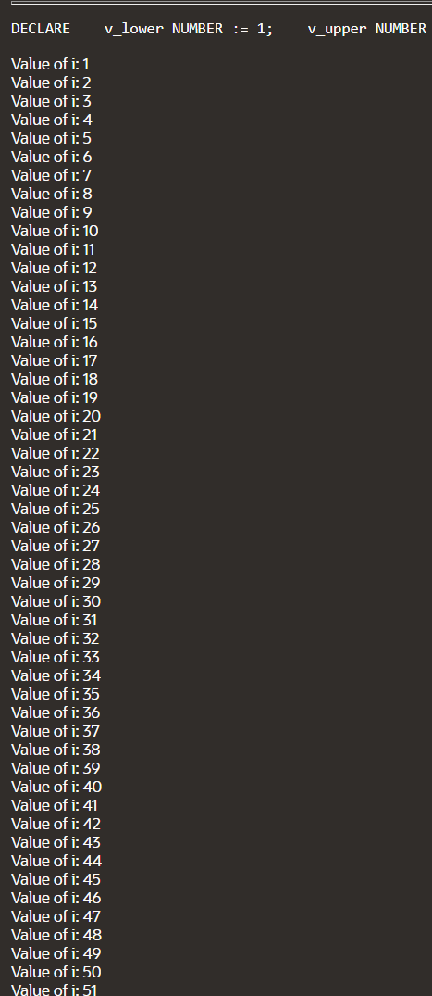

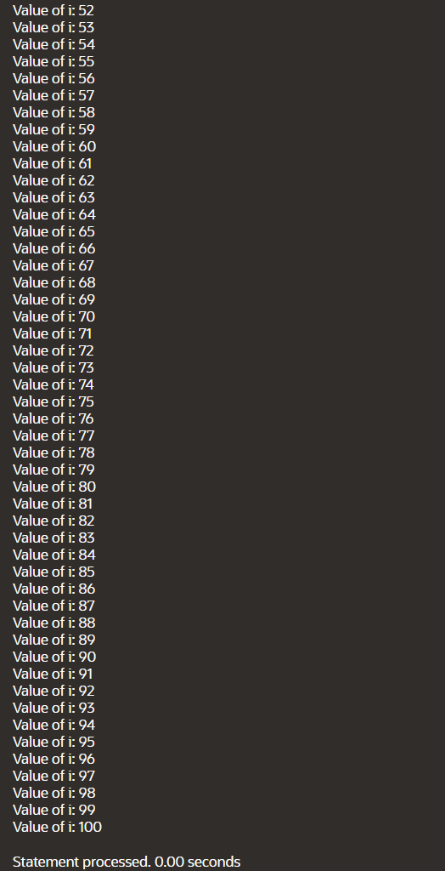

4-5 :-

ITERATIVE CONTROL : NESTED LOOPS :-

NESTED LOOP :-

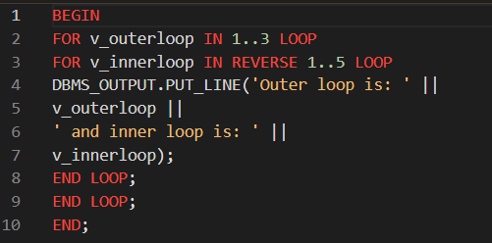

OUTPUT :-

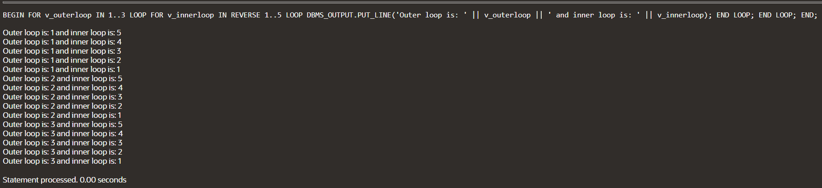

LOOP LABLES :-

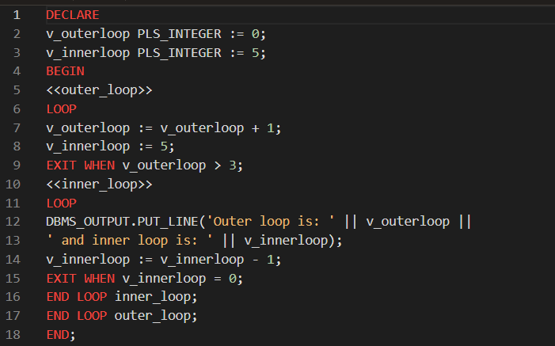

OUTPUT :-

